PRAWN: Palaemon malcolmsonii

1. Habit and Habitat of Prawn:
The prawn is common in rivers, ponds and other fresh-water areas. It is nocturnal, bottom-dweller and lives within underwater crevices and aquatic vegetation’s. It takes all kinds of food specially decaying leaves. It is a good swimmer but is also capable of crawling on the surface and at the time of danger can jump backwardly. It may attain a length up to seventy-five centimetres.

2. External Structures of Prawn:
The body of Prawn is elongated, hemispherical and slightly tapering at the posterior end (Fig. 18.2). The fresh specimen is slightly bluish in colour. The entire outer surface of the body is covered by hard exoskeleton. The body is distinctly divided into two parts— cephalothorax and abdomen. Both these parts bear on their ventral surfaces paired appendages, which are specialised for different functions.
Each appendage is biramous, i.e., two branched, and in spite of their modifications are built up on the same general plan:
(1) Lower, double-jointed protopodite containing proximal coxa and distal basis and
(2) Two branches or rami on the basis, the outer one is exopodite and inner one is called endopodite.
In addition to the appendages, the two halves of the body bear several other structures.
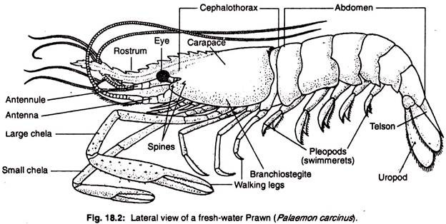
Cephalothorax:
Cephalothorax is the broad, un-segmented and cylindrical anterior part. It is formed by the fusion of head and thorax. In fact, during the development of prawn, one pre-segmental region and first fourteen segments fuse to form cephalothorax. The pre-segmental region remains in adult and carries the stalked eye and the first segment disappears during the process of transformation.
A continuous shield-like exoskeletal covering, called carapace, encloses the cephalothorax. On both the ventrolateral sides,the carapace-hangs freely over the gill-chamber as gill-cover or branchiostegite. The branchiostegite is raised and lowered by a thin membrane, branchiostegal membrane. Ventrally, the carapace is covered by several hard sternal plates.
Following structures are present on the cephalothoracic region:
(1) Rostrum:
On the dorsal and median surface, the carapace is drawn into a long serrated projection towards the anterior end. This is defensive in function.
(2) Eye:
Near the base of the rostrum and on each side of the carapace is placed an eye. Each eye is black and hemispherical and made up of several visual elements. It is thus called compound eye and it is mounted on a movable and jointed stalk. It is responsible for detecting light.
(3) Spines:
These are small pointed structures, present in pairs on each lateral side of the carapace and posterior to each eye. The anterior pair is known as antennal spines and the short posterior pair is the hepatic spines.
(4) Appendages:
Thirteen pairs of appendages are present on the ventral side of prawn. The close apposition of these appendages speaks about the fusion of cephalothoracic segments.
The first five pairs, i.e. First antenna or Antennule, Second antenna, Mandible, First maxilla or Maxillula and Second maxilla are known as cephalic appendages. The remaining eight pairs are called thoracic appendages or periopods, which include three pairs of Maxillipeds and five pairs of walking legs.
(a) First antenna:
First antenna is also known as antennule (Fig. 18.3A). It is placed near the base of the eye stalk. Its protopodite carries an additional segment, a spiny precoxa. The basis is longer than coxa and probably its exo and endopodites are modified as feelers or flagella.
The outer feeler has two branches and the smaller branch carries olfactory setae, probably for determining smell. The precoxa carries the balancing organ, called statocyst and the coxa is beset with many sensory hairs.
(b) Second antenna:
It is situated immediately after the first antenna. The coxa contains a specialised organ, called green gland, or antennal gland (or maxillary gland), which serves as excretory organ.
The exopodite is modified as a leaf-like squama or scale with setae along its inner margin (Fig. 18.3B). The scale serves as a balancer during swimming. The endopodite has become a long many-jointed flagellum and carries numrous tactile setae.
(c) Mandible:
It is placed on the outer side of the mouth and is responsible for crushing the food. In its protopodite, the coxa is modified to form as spoon-shaped proximal apophysis and solid distal part called head (Fig. 18.3C).
The head contains stout molar process with five to six yellow teeth and thin incisor process with three closely set white teeth. The basis portion of protopodite and the endopodite form a three- jointed mandibular palp, which remains in front of the head of the mandible and carries sensory setae. The exopodite is absent.
(d) First maxilla or Maxillula:
This crown-shaped smallest appendage (Fig. 18.3D) is placed slightly posterior to the mouth. It consists of three small leaf-like plates carrying sensory setae in their margins.
Two to these plates (formed by coxa and basis) are projected inwards and are called jaws or gnathobases or endites. The remaining plate is endopodite and is directed outwards. The exopodite is absent. The first maxilla is responsible for pushing the food inside the mouth.
(e) Second maxilla:
It is fan-shaped (Fig. 18.3E) and placed immediately after the first maxilla. The coxa is much reduced and the basis is bifurcated and directed inwards to form endites or jaws. The exopodife is large, fan-shaped and known as scaphognathite or batar.
The endopodite is small and placed between the basis and exopodite. The second maxilla serves double functions—jaws are for food-getting and the scaphognathite is for producing constant water current within the gill chambers.
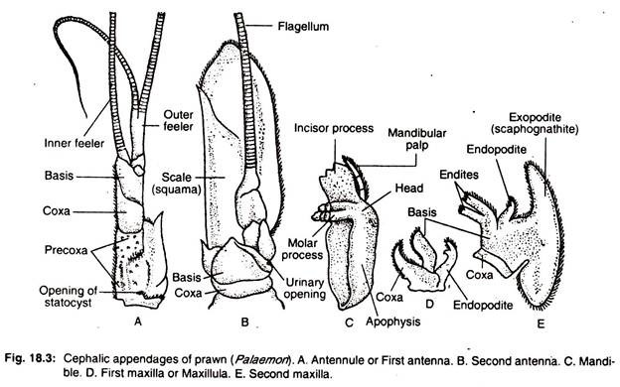
(f) First maxilliped:
The coxa and basis of the protopodite are flattened to become jaws and bear stiff setae on their inner margins (Fig. 18.4A). In addition to short endopodite and long exopodite, the coxa bears a bilobed epipodite. The exo and endopodite parts of coxa together with basis help in the in-pushing of food. The epipodites help in respiration.
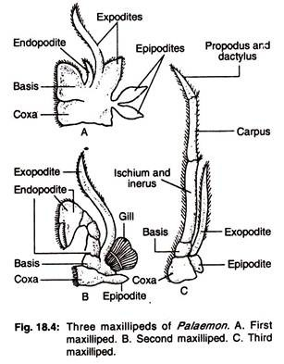
(g) Second maxilliped:
Here the short coxa carries on its outer margin a small epipodite and a gill (Fig. 18.4B). The inner margin is lined with numerous setae. The exopodite is long and un-jointed but the endopodite is made up of five segments— ischium, merus; carpus, propodusand dactylus. The last two segments are curved backwards to form a knife-like structure.
(h) Third maxilliped:
This appendage is leg-like (Fig. 18.4C) and its coxa carries a thin epipodite on the outer side. The exopodite is thin and un-jointed but the endopodite has three segments—proximal, middle and distal. The proximal segment is formed by the fusion of ischium and merus, middle is carpus and the distal segment is formed by the fusion of propodus with dactylus.
The three pairs of maxillipedes take part in feeding and hold the food in position while the mandibles masticate it. They are also helpful in respiration as they bear gills and epipodites.
(i) Walking legs:
There are five pairs of walking legs for crawling. Each leg has a short protopodite with distinct coxa and basis and a prominent five segmented endopodite (Fig. 18.5). These endopodite segments are ischium, merus, carpus, propodus, and dactylus.
The epi- and exopodites are absent. The first and second legs possess pincers formed by the attachment of dactylus on propodus and are called chelate legs, while the rest are known as non-chelate legs. The second walking leg being the largest is known as large chela and the first walking leg is called small chela.
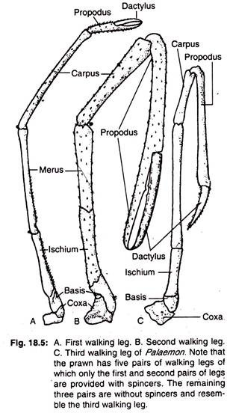
Chelate legs are used to grasp food and pass it on to the mouth. They also serve as organs of offence and defence. The second chelate legs in male are larger and more powerful than in female.

The third, fourth and fifth pairs of legs are non-chelate and typical. In female, each third leg bears a female reproductive aperture on the inner side of the coxa. While in male, each fifth leg bears a male genital aperture on the arthrodial membrane between the leg and thorax.

(5) Different apertures in cephalothorax:
(a) Mouth:
The mouth is a slit-like unpaired and median aperture on the ventral side of the cephalothorax and is situated in between third and fourth segments. It is encircled by mandibles, maxillae and first maxillipeds. It is concerned with the ingestion of food.
(b) Renal apertures:
It is present as a minute opening on a raised papilla near the base of each second antenna. It serves as an outlet of excretory duct from the excretory organ, green gland.
(c) Gonopores:
The position of these paired openings depends upon the sex of the individual. In males, the gonopores are seen on the inner sides of the coxae of fifth walking legs and in females these are in similar positions on the third walking legs.
(d) Statocyst openings:
Tine statocysts or the balancing organs of prawn communicate with the exterior through minute pores. There are two statocysts situated one on the base of each first antenna.
Abdomen:
The abdomen is composed of six distinct segments and a posterior-most triangular telson. Each abdominal segment is laterally compressed and is bounded by a ring-like exoskeletal piece, called the sclerite.
The sclerite of one segment covers the sclerite of the following segment. Such imbricately arranged sclerites are united with each other by thin un-calcified arthroidal membrane. Each sclerite consists of a ventral plate-like sternum and a dorsal arch-shaped tergum (Fig. 18.6).
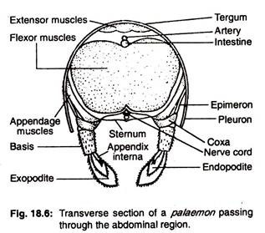
The tergum suspends freely on the lateral sides as pleuron. The pleuron is connected with the appendage of the corresponding side by a small plate-like epimeron.
The imbricate arrangement of the sclerites and its hinge-like joints (marked by orange spots) permit free vertical movements of the abdomen. Each abdominal segment carries a pair of appendages on its ventral sides. These appendages are called pleopods and the last pair is modified and known as uropods.
(a) Pleopods or Swimmerets:
One pair of pleopods is present in each of the first five abdominal segments. In each pleopod the protopodite has a longer basis than the coxa (Fig. 18.7A-C). The exopodite is longer than the endopodite. Both the exo and endopodites bear tactile setae but the former is larger.
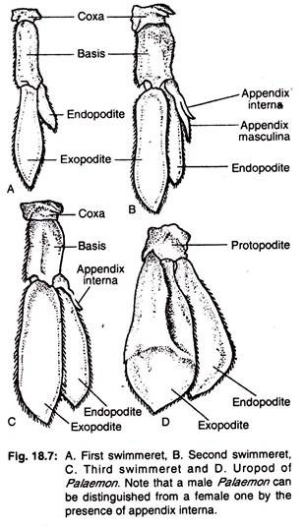
An additional hook-like process, appendix interna is present on the inner sides of the endopodites of 2nd, 3rd, 4th and 5th pleopods. These processes of both the sides in females unite to form a basket for carrying eggs. The second pleopods of the male prawn have an additional process which is known as appendix masculina. The pleopods are primarily meant for swimming.
(b) Uropod:
One pair of uropods is present in the last segment, one on each side of the telson (Fig. 18.7D). The protopodite is one segmented but the exo- and endopodites are large and fan-shaped. The exopodite is divided by a fine suture but the endopodite is not sutured. The tactile setae are arranged at the margin of both the exo- and endopodites. The uropods are used for changing direction and also for leaping backwards.
Only one aperture called anus is present near the base of the telson on its ventral side. This is the opening of alimentary canal for the purpose of egestion.

3. Locomotion of Prawn:
The prawn moves in three different ways—crawling, swimming and darting. At the time of crawling the animal straightens its body and rests over five pairs of walking legs. The legs are moved in harmony and the feelers of the antennae are directed forward to survey the environment. The swimmerets move like paddle during swimming and look like oars.
The third type of locomotion, darting, occurs to evade danger. During this type of movement, the animal curves its abdomen under the cephalothorax and exerts pressure on the surface by the expanded uropod’s and telson. This gives a backward thrust, which shifts the body to a considerable distance in backward direction.

4. Digestive System of Prawn:
The digestive system of Prawn consists of (A) Alimentary canal and (B) Digestive glands (Fig. 18.8).
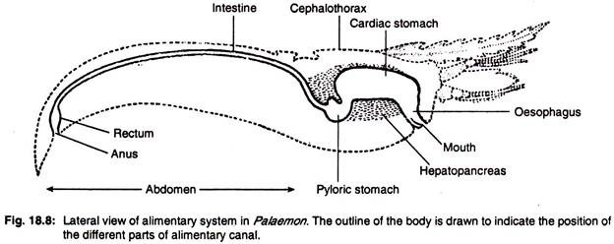
A. Alimentary canal:
The alimentary canal of Prawn is distinctly divisible into three parts—fore gut, mid gut and hind gut.
1. Fore gut:
It is internally lined by thick cuticle and consists of following parts:
(a) Mouth:
It is a broad opening on the ventral side of the cephalothorax between the third and fourth segments. It is bordered anteriorly by shield-like labrum, posteriorly by two-lobed labium and laterally by the incisor processes of the mandibles.
(b) Buccal cavity:
A small anterio-posteriorly flattened chamber between the mouth and oesophagus. It has an irregularly folded lining of cuticle.
(c) Oesophagus:
It runs vertically upwards as a broad tube from the buccal cavity and leads to the stomach. The inner lining is muscular and has one anterior, two lateral and one posterior folds.
(d) Stomach:
This is the longest part of the fore gut which is placed longitudinally within the cephalothorax.
It is divided into two parts:
(i) Cardiac stomach:
It is large, spacious and bag-like anterior part of the stomach. Its inner cuticular wall is provided with ridges having minute bristles. Following plates support its wall—circular plate in the anterior part, lanceolate plate on the dorsal side of the posterior part and a shield-shaped hastate plate in the mid-ventral region (Fig. 18.9). The posterior part of the hastate plate is depressed and reaches up to the cardio-pyloric opening.
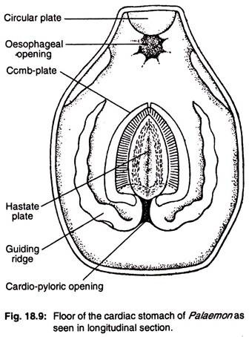
The upper part is slightly convex and gradually slopes towards the two lateral sides from a distinct median ridge in the middle. Both the upper and posterior surfaces have delicate setae. On each lateral side of the hastate plate lies an elongated lateral groove. A cuticular supporting rod and a ridged plate of similar nature, bound the inner and outer sides respectively of each lateral groove.
The inner side of each ridged plate is provided with rows of comb-like setae, which are known as comb-plate. The bristles of the comb-plate partially cover the lateral side of the hastate plate. The comb-plates of two sides unite at the anterior end but remain free at the posterior end just near the cardio- pyloric opening.
The inner wall of the cardiac stomach on the side of each comb-plate is folded to form a longitudinal channel, called the guiding ridge. The two guiding ridges posteriorly form the border of the cardio-pyloric opening.
(ii) Pyloric stomach:
The cardiac stomach opens within th6 next part, pyloric stomach through a narrow, X-shaped cardio-pyloric opening. The opening is guarded by one anterior, one posterior and two lateral valves. The anterior valve is the posterior extension of hastate plate, posterior one is the fold of stomach wall and the two lateral valves are the projections of the guiding ridges.
The pyloric stomach is much smaller and narrower than cardiac stomach. Its lateral muscular wall is incompletely divided by folds into a small dorsal chamber and large ventral chamber. The ventral chamber receives the duct from the digestive gland, hepatopancreas and is divided into two lateral compartments.
The floor of the ventral chamber has a rectangular filter plate having alternate ridges and grooves. This filter plate together with the bristles on the lateral wall of ventral chamber, acts as pyloric filtering apparatus. This filter permits only liquid food to enter into the intestine.
2. Mid gut:
It is the narrow and elongated part of the’ intestine, which begins from the dorsal chamber of pyloric stomach and runs along the mid-dorsal line up to the sixth abdominal segment. Its internal epithelial lining at the posterior part is folded. Thus the space within the tube is reduced.
3. Hind gut:
It is also lined by thick cuticle and consists of following parts:
(a) Rectum:
It is the swollen muscular region of the last part of intestine having number as internal folds.
(b) Anus:
This is the aperture through which the alimentary canal opens to the exterior. It is a ventrally placed longitudinal slit-like opening, present near the base of the telson on a raised papilla.
B. Digestive gland:
Only one digestive gland, hepatopancreas, is present. It is an orange-yellow coloured, loosely arranged bilobed organ which encircles completely the pyloric stomach, part of the intestine and partly the cardiac stomach. One hepatopancreatic duct originates from each lobe independently and opens separately within the pyloric stomach, immediately after the pyloric filter plate.
The hepatopancreas in its role as digestive gland serves as liver, pancreas and intestine of higher animals. In addition, it absorbs digested food and can store it for future use. Thus, this organ serves double functions—digestion and storage.
Mechanism of Nutrition:
The process of nutrition involves three stages—ingestion, digestion and egestion.
Ingestion:
Prawn is omnivorous, i.e., eats all kinds of foods. It feeds actively at dusk and in the morning on algae, decaying vegetables and small insects. Food is procured by the chelate legs and brought near the mouth cavity by following appendages— maxillipeds, maxillulae and maxillae.
Mandibles help to fragment the food into smaller bits and the molar processes of the mandibles inside the buccal cavity crush the food. Entrance of food within the cardiac stomach is assisted by the peristaltic motion of the oesophageal wall.
Digestion:
Within the cardiac stomach the food is churned by the action of cuticular plates on the inner wall, finer particles of food filtered by the complete come within lateral grooves from where it is guided into the ventral chamber of pyloric stomach.
Digestion takes place within the pyloric stomach by the action of digestive juices which come from the hepatopancreas. All the enzymes for the breakdown of carbohydrate, protein and lipid are present in the juice.
The digested liquid food is strained by the filtering apparatus in the ventral chamber of pyloric stomach and enters within dorsal chamber and then to the hepatopancreas. The residual part of the food passes within the mid gut. After certain amount of absorption the residual matter enters within dorsal chamber and then to the hepatopancreas. The residual part of the food passes within the hind gut.
Egestion:
From intestine the residual part of the food enters within the rectum and is temporarily stored there for some-time. Finally it is ejected through the anus.

5. Respiratory System of Prawn:
Prawn respires in the aquatic medium and it carries three sets of organs for the purpose—lining of the branchiostegite, epipodites and gills. All these organs are enclosed within a special chamber on each side of the cephalothorax, which is called gill-chamber.
The gill-chamber is covered by the lateral extension of carapace, called gill- cover or branchiostegite. Each gill-chamber is thus open ventrally, anteriorly and posteriorly.
A. Lining of the branchiostegite:
The richly vascularised membrane of the branchiostegite serves as respiratory surface, through which gaseous exchange takes place.
B. Epipodites:
These are small highly vascularised leaf-like membranous structures, one on the coxal segment of each maxilliped. These epipodites being present in the anterior part of the gill-chamber carry out respiratory functions.
C. Gills:
Among the three sets of respiratory organs, the gills are regarded as primary respiratory organs. On each lateral side of the cephalothorax and beneath the branchiostegites, there are eight gills (Fig. 18.10), each attached with the thoracic wall by a gill-root. Seven of these eight gills are serially arranged, while the eighth gill remains concealed under the second gill.
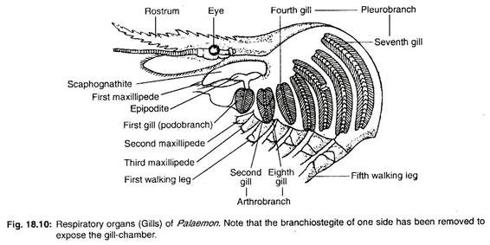
Structure:
The gills are crescent-shaped and their sizes increase gradually from anterior to posterior direction. Each gill consists of a slender axis or base on which double rows of rhomboidal leaf-like gill-plates are arranged like the pages of a book.
According to their position and mode of attachment, the gills are of three types:
(i) Podobranch—attached with the coxa of the second maxilliped.
(ii) Arthrobranch—attached with the arthroidal membrane of third maxilliped.
(iii) Pleurobranch—attached with the outer border of the thorax and over the articulating surface of the walking legs.
In prawn, the first gill is podobranch, second and eighth gills are arthrobranchs and remaining five gills are pleurobranches.
Histology:
Histological structure of the gill shows that gill base has following layers— the outermost cuticle, inner epidermis and innermost connective tissue mass. Each gill- plate is formed by monolayer of cells, sand- witched between two layers of cuticle. The cellular layer includes two alternately arranged cell types—pigmented and transparent.
Blood supply:
Two lateral and one median longitudinal blood channels pass throughout the length of gill-base. The two lateral channels are interconnected by numerous transverse channels.
From each lateral channel a slender marginal channel is given to each plate. After covering the entire margin of the plate, the marginal channel opens within the median channel. The gill receives deoxygenated blood through afferent branchial channels.
Each branch of afferent channels opens within the transverse channels. From transverse channels the blood passes to the lateral longitudinal channels and is distributed subsequently within the gill-plates through the marginal channels. After oxidation, the blood from marginal channel returns to the median channel and then to the efferent branchial vessels, which convey it to the heart.
The course of circulation of blood through the gill is given below:
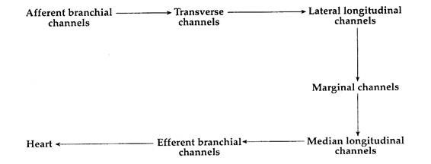
Mechanism of Respiration:
The scaphognathites of maxillae and exopodites of maxillipeds are responsible for forcing the water to rush inside the gill- chamber through posterior and lateral sides. This water passes out through the anterior end.
During the flow of water the vascularised surface of the branchiostegites, gills and epipodites are bathed and gaseous exchange occurs through these areas when dissolved oxygen is taken in and carbon dioxide passes from the body to the exterior.

6. Circulatory System of Prawn:
The blood circulation in prawn is open type, i.e., blood flows through the body spaces. Such spaces are called haemocoels. The circulatory system includes—blood, heart, true blood vessels and haemocoelomic spaces.
A. Blood:
Blood includes both the circulating fluid and the body fluid. The cellular part of the blood includes only amoeboid leucocytes. The liquid part, plasma, contains a copper-containing respiratory pigment haemocyanin in dissolved state. This pigment is responsible for the blue colouration of the blood. The blood can coagulate very rapidly.
B. Heart:
It is more or less a triangular organ with inner spongy cavity. It is placed beneath the carapace and above the gonads.
Heart is united with the pyloric stomach by a cardio-pyloric strand. The anterior end of the heart, called the apex is pointed and the broad end base is directed posteriorly.
The entire structure is enclosed within a haemocoelomic space, called pericardial sinus, the wall of which serves as pericardium. Two lateral and one median longitudinally fibrous tissue strands connect the heart with the body wall and thus fix it to its position inside the pericardium.
The wall of the heart is pierced by five pairs of slit-like openings, called ostia. There are two pairs on the lateral sides, one pair in the ventral, one pair in dorsal and one pair at the posterior end of the heart. These ostia are contractile and work as valves to permit only flow of blood from pericardial sinus to the heart.
C. True blood vessels:
These are the vessels which possess definite walls. As all of them originate from the heart to supply blood to different parts of the body, they are better called arteries. From the heart of prawn six large vessels originate.
They are:
(i) single ophthalmic artery,
(ii) paired antennary arteries and
(iii) paired hepatopancreatic arteries— all originate from the anterior end and
(iv) a single mid-posterior artery emerges from the posterior end (Fig. 18.11).
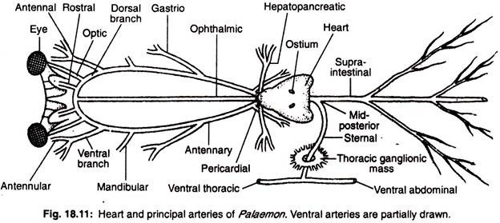
(i) Ophthalmic artery:
The single ophthalmic or cephalic artery originates from the apex of the heart and runs anteriorly along the mid-dorsal line up to the base of the rostrum and unites with the branches of two antennary arteries.
(ii) Atennary artery:
Each antennary artery originates from the heart and from the sides of the ophthalmic artery. It runs anteriorly along the outer border of the mandibular muscle.
Each antennary artery sends the following branches on its own side:
(a) Pericardial branch to supply blood to the pericardial wall,
(b) Gastric branch to supply blood to the cardiac stomach,
(c) Mandibular artery to the muscle of the mandible. Each antennary artery then splits into,
(d) A ventral, and
(e) A dorsal branch.
The ventral branch supplies vessels to the first and second antennae. The dorsal branch sends an optic artery to the eye and then the two dorsal branches of the two antennaries unite with the median ophthalmic artery to run within the rostrum as paired rostral arteries.
(iii) Hepatopancreatic artery:
The hepatopancreatic or hepatic artery of each side originates from the posterio-median end of the heart and runs transversely to enter within the hepatopancreas.
(iv) Mid-posterior artery:
The midposterior artery immediately after originating from the posterio-median end of the heart divides into:
(a) Supra-intestinal artery and
(b) Sternal artery.
The supra-intestinal which is also known as dorsal abdominal artery runs posteriorly along the mid-dorsal line up to the hind gut. It supplies the alimentary canal and the muscles on the dorsal sides.
The sternal artery runs transversely towards the ventral side. It pierces the thoracic ganglion mass and bifurcates into an anteriorly directed ventral thoracic and a posteriorly directed ventral abdominal arteries.
The ventral thoracic artery supplies blood to the different parts on the ventral side of the cephalothorax and ventral abdominal sends branches to the ventral side of the abdomen.
All the arteries ultimately break up into finer branches and open within the haemocoelomic spaces. Thus the Circulatory system of prawn lacks network of capillaries.
D. Haemocoelomic spaces:
Small haemocoelomic spaces are called lacunae. These lacunae open into larger spaces, called sinuses. The passages connecting lacunae and sinus or two sinuses are known as haemocoelomic channels.
Blood after flowing through different small haemocoelomic spaces or lacunae is collected in a pair of common elongated space, called ventral sinus. These are placed beneath the hepatopancreas and continued up to certain length within the abdomen. The two ventral sinuses are interconnected by several small slender channels.
From the ventral sinus six afferent branchial channel take the deoxygenated blood to the gills. First afferent branchial channel supplies blood to the podobranch and arthrobranchs while the remaining five vessels supply to the five pleurobranchs.
From gills oxygenated blood is collected by six pairs of efferent branchial channels and is finally drained into dorsal or pericardial sinus.
Mechanism of blood flow:
The heart contracts to drive the oxygenated blood to the different parts of the body through arteries (Fig. 18.12). These arteries instead of forming capillary network open directly within haemocoelomic spaces. From different haemocoelomic lacune deoxygenated blood is collected within paired ventral sinuses.
From these large spaces, blood is sent for oxidation to the respiratory organs through the afferent branchial channels. From gills the blood returns to the pericardial sinus through efferent branchial channels.
When the pericardial sinus is full its wall starts to contract and forces the blood to enter within the heart through ostia. When heart contracts the lip-like borders of the ostia close and thus blood is permitted to travel only through arteries.
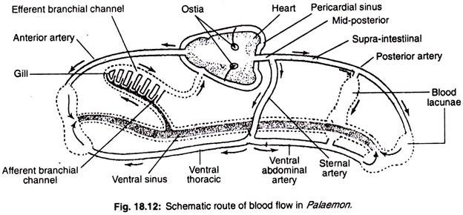

7. Excretory System of Prawn:
Excretory organs of Prawn are known as green glands or antennal glands (Fig. 18.13). They are called green glands for their colour and antennal gland for the location at the base of the second antennae. The green colour is seen in Astacus. These are paired white organs. Each organ remains within the coxa of each second antenna.
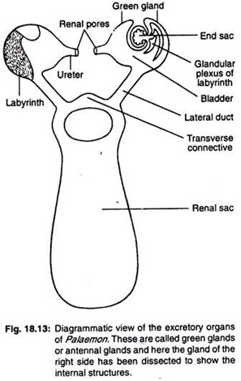
The organ consists of following parts:
(A) End sac:
This small bean-shaped part contains a blood lacuna. Its wall is two- layered, the inner layer is of epithelial cells having excretory function and the outer thick connective tissue layer has minute lacunae. Radially arranged partitions, called septa, project from the wall within central cavity.
(B) Labyrinth:
Present outside the end sac and contains many narrow, branched and coiled excretory tubules. Each tubule communicates with the end sac by a single opening but opens within the bladder through several apertures. A single epithelial cell layer having excretory function lines each tubule.
(C) Bladder:
It is a thin-walled sac with an epithelial lining. It communicates with the exterior through a small ureter.
(D) Excretory opening:
It is present on the base of each second antenna. Both the green glands are connected with a common large thin-walled transparent and centrally placed sac, called the renal sac. It is present between the cardiac stomach and the carapace and it communicates with the bladder of each green gland by a separate lateral duct. The two lateral ducts are interconnected by a transverse connective.

8. Physiology of Green Glands of Prawn:
The green glands perform two important functions:
1. Elimination of nitrogenous waste products and
2. Maintains the osmotic equilibrium.
1. Elimination of nitrogenous waste products:
End sac and the labyrinth are the two regions responsible for extracting urine from the blood. The most nitrogenous products include ammonia, a major excretory product in all crustaceans (the ammonia compounds are excreted by end sac in only aquatic crustaceans), and also urea and uric acid.
The excretory products are conveyed by the excretory ducts of the labyrinth from the surrounding blood of the haemocoel.
Ultrafiltration of the blood takes place across the wall of the end sac. The labyrinth walls are folded and glandular which are considered as the site of selective reabsorption. The primary urine is modified when it passes through the parts of the excretory system. The urine remains temporarily stored within the bladder and is periodically expelled through renal pore.
2. Maintains the osmotic equilibrium:
The excess water which enters the body is separated from the body fluid by the green glands to maintain osmotic equilibrium and volume regulation of the body fluid is achieved.
In addition to green glands, gills and integumental covering are also responsible for excretion. The exoskeleton at the time of its periodic replacement carries a large quantity of excretory products.

9. Nervous System of Prawn:
Nervous system resembles the annelidan pattern but shows considerable advancement.
It is divisible into:
(A) Central nervous system,
(B) Peripheral nervous system and
(C) Autonomic nervous system.
It also includes several sense organs to permit the entry of different messages from outside.
A. Central nervous system:
The central nervous system runs from anterior to posterior end (Fig. 18.14) and contains following structures:
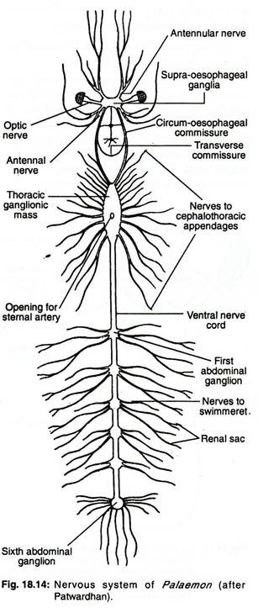
1. Brain:
It is made up of a pair of supraoesophageal ganglia which are placed dorsally and near the base of the rostrum. It sends a number of peripheral nerves to the different organs at the anterior end of the cephalothorax.
2. Circumoesophageal connectives:
These are a paired cord, each of which begins from the supraoesophageal ganglion of one side and runs posteriorly along the ventrolateral wall of the cephalothoracic cavity. A small ganglion is present in each commissure to supply nerve to the mandibles.
The two cords are connected by a thin nerve, called transverse loop, which is present immediately after the oesophagus. The two connectives ultimately unite at the floor of the thoracic cavity with a large ganglion, called the thoracic ganglionic mass.
3. Thoracic ganglionic mass:
A large ventral elongated mass is formed by the fusion of eleven pairs of ganglia. Two circumoesophageal connectives are united with it at the anterior end. This ganglionic mass is pierced by the sternal artery. It sends eleven pairs of peripheral nerves.
4. Ventral nerve cord:
From the posterior end of the thoracic ganglionic mass originates ventral nerve cord which runs up to the posterior-most segment. The cord appears to be single but in reality it is formed by the fusion of two separate cords. The ventral nerve cord along its course bears a ganglion in each segment. The last ganglion or 6th ganglion is the largest of all the abdominal ganglia and known as stellate ganglion.
B. Peripheral nervous system:
The peripheral nerves are given off from the different parts of the central nervous system. Each peripheral nerve contains two kinds of fibres—motor and sensory. The motor fibres carry instructions from the central nervous system to different parts and the sensory fibres are meant for bringing messages from different corners of the body.
Following peripheral nerves are seen in prawn:
1. Optic nerve:
From each lobe of brain, an optic nerve enters within the eye to innervate the retinal layer.
2. Antennular nerve:
From each lobe of brain an antennular nerve is given within the first antenna or antennule to supply statocyst and various other structures present in the first antenna.
3. Antennary nerve:
From the posterior side of each lobe of brain, antennary nerve originates and runs posteriorly to take a quick turn towards the anterior dissection to supply the various parts within second antenna including green gland.
4. Cephalothoracic nerves:
Eleven pairs of cephalothoracic nerves originate from the thoracic ganglionic mass to supply different muscles and appendages in that region.
5. Abdominal nerves:
From each abdominal ganglion two ‘pairs of peripheral nerves are given off to the corresponding segments to supply muscles and appendages. The stellate ganglion in addition to these two pairs sends several more branches to telson, rectum and other adjoining structures.
C. Autonomic nervous system:
It includes a few minute ganglia and slender nerves which are present over the cardiac stomach to supply involuntary parts of the body.
D. Sense organs:
Following sense organs are present in prawn to receive different stimuli—tactile organs, olfactory setae, statocyst and eye.
1. Tactile organs:
These sense organs are present along the margin of antenna and other appendages.
A typical tactile seta (Fig. 18.15A) consists of:
(a) Swollen base or shaft and
(b) Pointed plumose with double rows of barbs.
These are responsible for the sensation of touch.
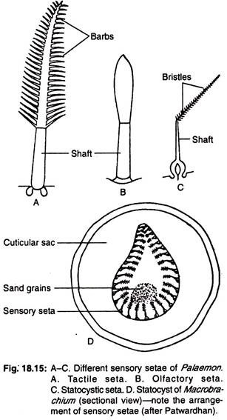
2. Olfactory setae:
These organs are present on the small inner branch of the outer feeler of the first antenna. These organs differ from tactile setae in the absence of the barbs in the plumose part (Fig. 18.15B). These are responsible for smell.
3. Statocyst:
Inside the base (pre-coxa) of each antennule, the statocyst is present as a small, white and spherical cuticular sac. In the central part of the sac, elongated and slender sensory setae are elliptically arranged.
Each seta (Fig. 18.15C) consists of a pointed bristled end, called shaft, which is directed inwards and an outer swollen base which is connected with a fine branch of statocyst nerve. In the area surrounded by the setae there are minute sand grains (Fig. 18.15D).
When the prawn moves, these inner sand grains are displaced at each change of position. These displaced sand particles press against the sensory setae. Finer branches of statocyst nerve carry the information from each seta to the brain and the animal corrects its loss of equilibrium.
4. Eye:
Each movable and stalked eye is compound in nature, i.e., made up of several simple visual units (Fig. 18.16A). Each unit is called an ommatidium or ocellus.
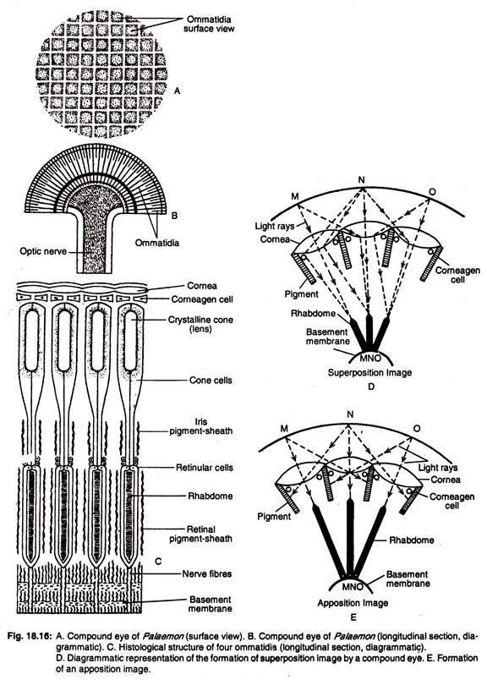
(a) Structure of an ommatidium:
Each ommatidium is divisible into two parts—outer dioptrical region for focussing the light rays falling from the object and inner retinal part or receptor region for receiving light stimuli and serves to form the image. The dioptrical region consists of cornea, corneagen cells, crystalline cone and cone cells. The receptor region includes rhabdome, retinular cells and pigment sheath.
These two portions (dioptrical region and receptor gerion) in each ommatidium contain following parts from outer to inner sides:
(i) Cornea:
It is the outermost transparent cuticular layer. The cornea of all the ommatidia gives the outermost part of the eye a graph paper-like appearance (Fig. 18.16B) and each square is called a facet. The cornea acts as a lens.
(ii) Corneagen cells:
Immediately beneath the cornea pair of corneagen cells is present which are responsible for the replacement of cornea (Fig. 18.16C).
(iii) Crystalline cone:
This is an elongated transparent body, placed beneath the corneagen cells and works as a second lens.
(iv) Cone cells or Vitrellae:
These cells are four in number and they encircle the cone or lens to provide nourishment.
(v) Rhabdome:
Elongated transversely striated body which is situated immediately beneath the cone cells.
(vi) Retinular cells:
These are elongated sickle-shaped cells. Seven such cells secrete the rhabdome and encircle it to provide its nutrition.
(vii) Pigment sheath:
Two separate sheaths containing chromatophores are responsible for separating one ommatidium from the other. The group of pigment sheath which is present around cone and cone cells is called iris sheath, while the other group around rhabdome and retinular cells is called retinal sheath. Pigment sheaths are able to contract and relax, which depends upon the intensity of light.
(b) Mechanism of image formation:
The ommatidia of a compound eye may work singly or collectively. Several adjacent ommatidia take part in the formation of an image and each ommatidium produces a separate image of a part of the object. Therefore, the whole image which is produced by the compound eye is made up several pieces of images. So the vision produced by the compound eye is known as mosaic vision (Fig. 18.16E).
During bright light both the pigment sheaths extend and completely separate the ommatidia, which result in the formation of a large number of images. These images are called apposition images. This type of vision is also called mosaic vision.
When light is dim, ommatidia work together to form a single but blurred image. Such image is called superposition image and the kind of vision is known as superposition image (Fig. 18.16D). Prawn can move its eye considerably and has nearly 360° vision.

10. Reproductive System of Prawn:
Sexes are separate in prawn and sexual differences (i.e., sexual dimorphism) are prominent. The gonads are of different shapes and both occupy similar position. The important differences between two sexes are shown in the table-18.1 Arthropoda.
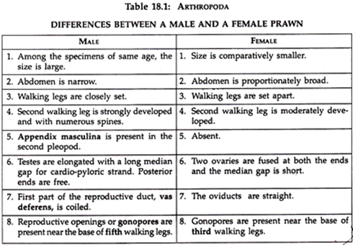
Male reproductive system:
It consists of following structures (Fig. 18.17A):
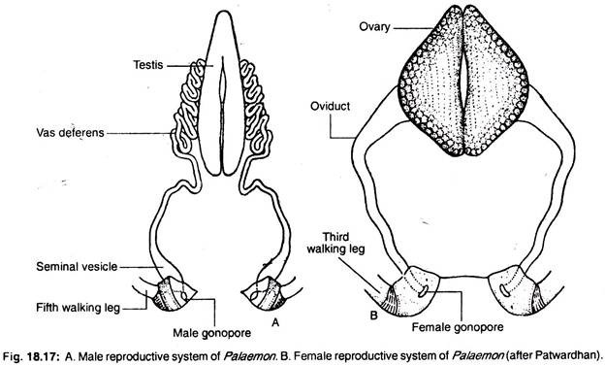
1. Testes:
These paired, soft and white organs are present above the hepatopancreas and beneath the heart. Anterior ends of the two testes are united but the posterior ends are free. Each testis includes numerous minute tubes, called seminiferous tubules, which remain enclosed within connective tissue. Each tubule has an inner lining of a single layer of epithelial cell which transforms into spermatozoa.
2. Vas deferens:
From the posterior end of each testis, a long much-coiled duct, called vas deferens, originates. It runs obliquely downwards and backwards between the thoracic wall and abdominal flexor muscles towards the fifth walking leg.
3. Seminal vesicles:
Each vas deferens near the base of the fifth walking leg is swollen as seminal vesicle. It serves as a chamber in which sperm cells are temporarily stored and transformed into small packets, called spermatophores.
4. Male gonopore:
The base of each fifth walking leg contains a small opening, called male gonopore, through which the seminal vesicle of the corresponding side opens. The gonopore is guarded by a small cuticular lid.
Female reproductive system:
It consists of following structures (Fig. 18.17):
1. Ovaries:
These paired white and compact organs are placed above the hepatopancreas and beneath the heart. The two ovaries are united at their both ends. Each ovary is bounded by a hard capsule within which egg cells or ova remain serially arranged. The matured eggs remain near the margin and the immature eggs occupy the centre.
2. Oviducts:
From the outer border and from near the middle of each ovary originates a short and wide oviduct which runs straight downwards to the third walking leg.
3. Female gonopore:
Present one on the inner side of each third walking leg as a small aperture is called the female gonopre or reproductive opening. It acts as an outlet of oviducts.

11. Breeding and Life History of Prawn:
Sperm cells are umbrella-like. The eggs or ova are rounding, yolk-filled and each egg contains a large nucleus. Reproduction takes place during rainy season. Fertilization is external, i.e., union of reproductive cells occurs outside the body.
The female prawn carries the fertilized eggs within the abdominal basket. The development is direct, i.e., young which hatches out of the egg resembles the adult in appearance. Quick moulting occurs during the growth of the young.

